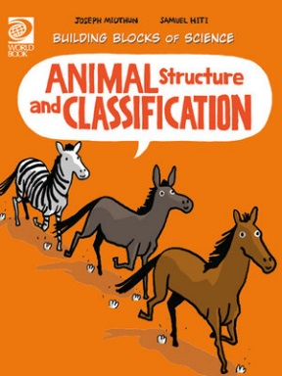
Animal Structure and Classification Activity Sheet
- True or False? Humans are part of the animal kingdom.
- How do we identify an animal?
________________________________________________________________________
- What is the science of naming and classifying animals, plants and other living things?
________________________________________________________________________
- What is Animalia?
________________________________________________________________________
- What is phylum?
________________________________________________________________________
- What do most animals in the Phylum Chordata have?
________________________________________________________________________
- What phylum does a monarch butterfly belong to and why?
________________________________________________________________________________________________________________________________________________
- What are animals without backbones called and give an example?
________________________________________________________________________
- What is the largest group of invertebrates called?
________________________________________________________________________
- What class do humans fall in?
________________________________________________________________________
- What does class include?
________________________________________________________________________
- What separates mammals from other vertebrates?
________________________________________________________________________
- What are orders?
________________________________________________________________________
- What order do humans, gorillas, orang-utans, monkeys and lemurs belong to?
________________________________________________________________________
- What family do humans belong to?
________________________________________________________________________
- True or False? Humans are the only living members of their genus.
- True or False? Humans do not belong to a genus called Homo.
- What is the basic level of scientific classification?
________________________________________________________________________
- What can animals who are part of the same species do?
________________________________________________________________________________________________________________________________________________
- Why do animals have a scientific name?
________________________________________________________________________
- List out the levels of classification in order.
K___________________________________________
P___________________________________________
C___________________________________________
O___________________________________________
F___________________________________________
G___________________________________________
S___________________________________________

ANSWERS:
- True
- Cells, organ systems and appearance help identify an animal.
- Taxonomy.
- All animals make up a kingdom called Animalia.
- Phylum is a large group of animals with many different kinds of living things in it.
- Backbones, they are vertebrates.
- The monarch butterfly belongs to a phylum of animals without backbones called Arthropoda.
- Animals without backbones are called invertebrates. Examples of invertebrates are sponges, jellyfish, clams, corals and some worms.
- Arthropods
- Mammals
- Class includes many living things that share more characteristics than other members of the phylum.
- Mammals grow hair, drink milk from their mother and keep the same body temperature.
- Orders are smaller groupings of animals in the same class.
- Primates.
- Homindae
- True
- False
- Species
- Members of the same species can reproduce and create offspring that can also reproduce.
- To avoid confusion between other animals that have similar features, scientists have use a scientific name.
- Kingdom
Phylum
Class
Order
Family
Genus
Species

