Make and Do Activities

Story Scramble

What You Need
- Paper and pencil
- Scissors

Who Plays
- 1 – 6 players

Skills
- Sequence

Prepare the scramble by writing out or photocopying a simple, unfamiliar children’s story. Then cut the sentences apart and mix them up. Ask each student to put the sentences in order to create a logical story.
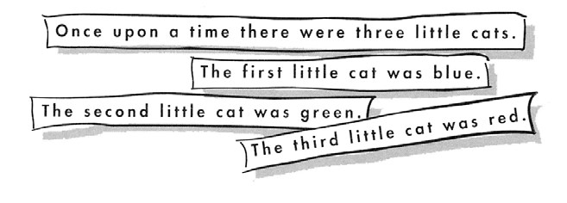

Variations
- For beginning readers, a story very familiar to them might be scrambled.
- Some students may wish to paste each sentence on a separate page and illustrate the pages, creating picture books.
- The concluding sentence could be omitted and the students asked to write a new conclusion to the story.
Early World of Learning© Welcome to Reading™ | Make and Do Activities |Story Scramble

