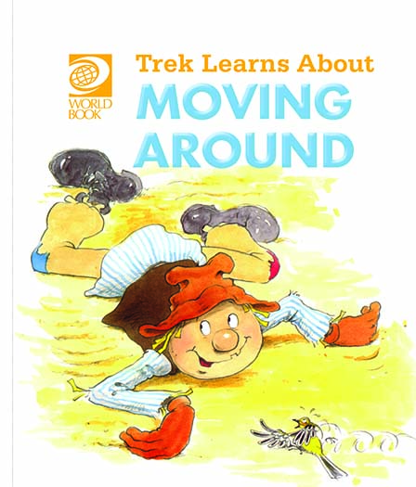
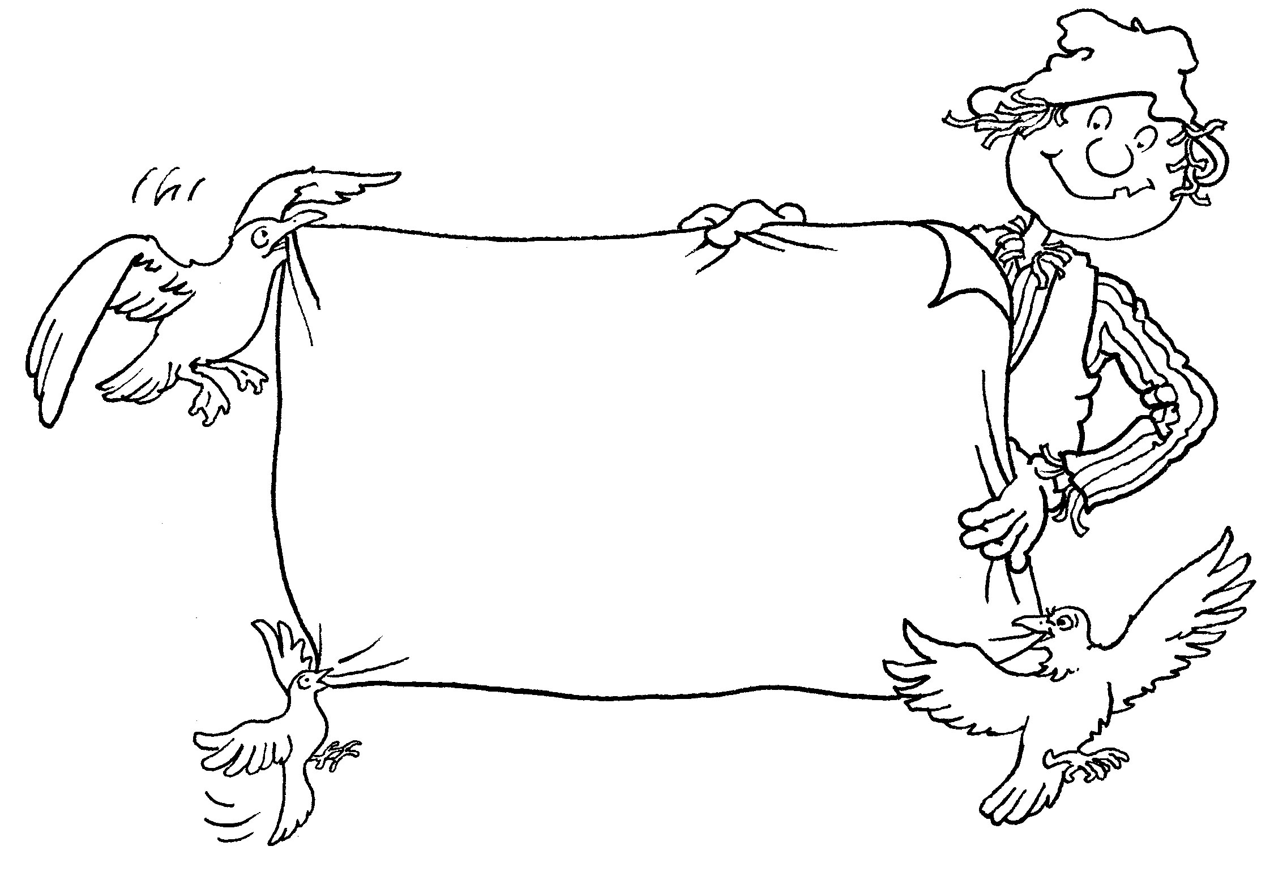
Trek’s Travels –

MOVING AROUND

Talking about movement
1. Do you remember what Trek has to do, in order to fly?
_________________________________________________________________
2. Can you flap your arms like Trek?
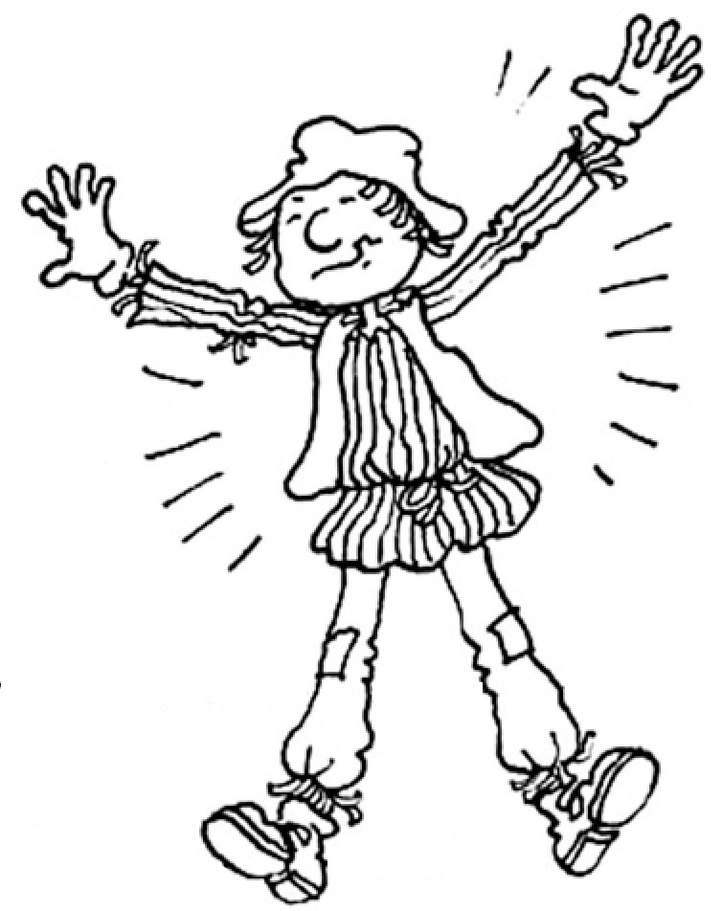
3. Can people fly?
_________________________________________________________________
4. How does a kangaroo move?
_________________________________________________________________
5. Can you leap like a kangaroo?
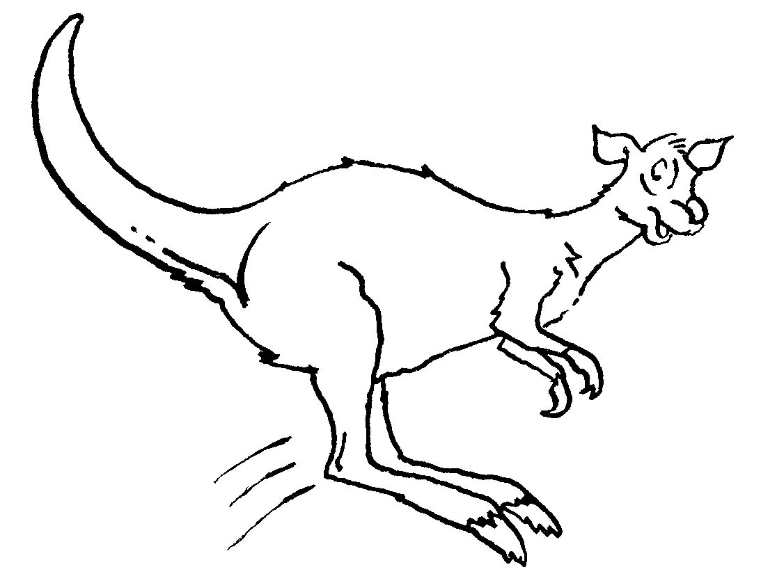
6. How does a koala move?
_________________________________________________________________7. Can you climb like a koala?
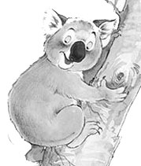
8. How does a kookaburra move?
_________________________________________________________________9. Can you twist and turn like a kookaburra?
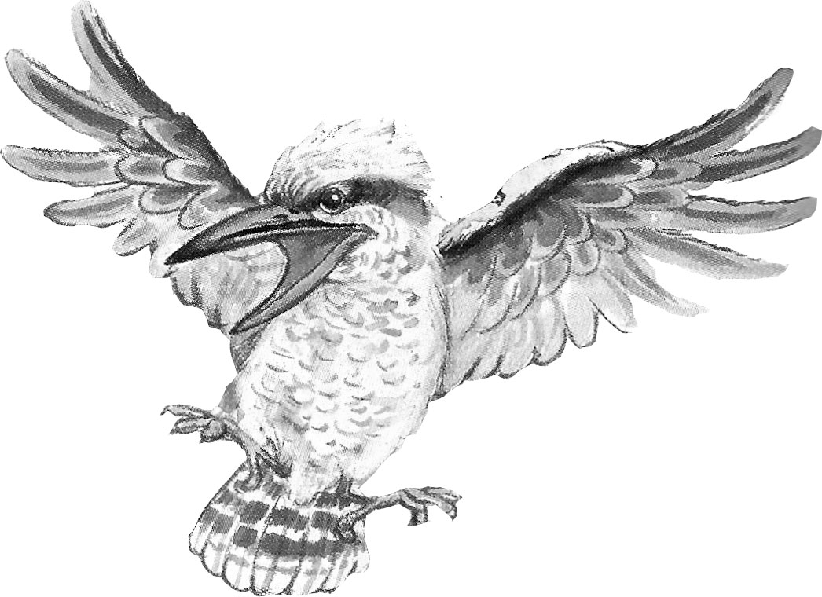
10. Which animal can gallop?
_________________________________________________________________
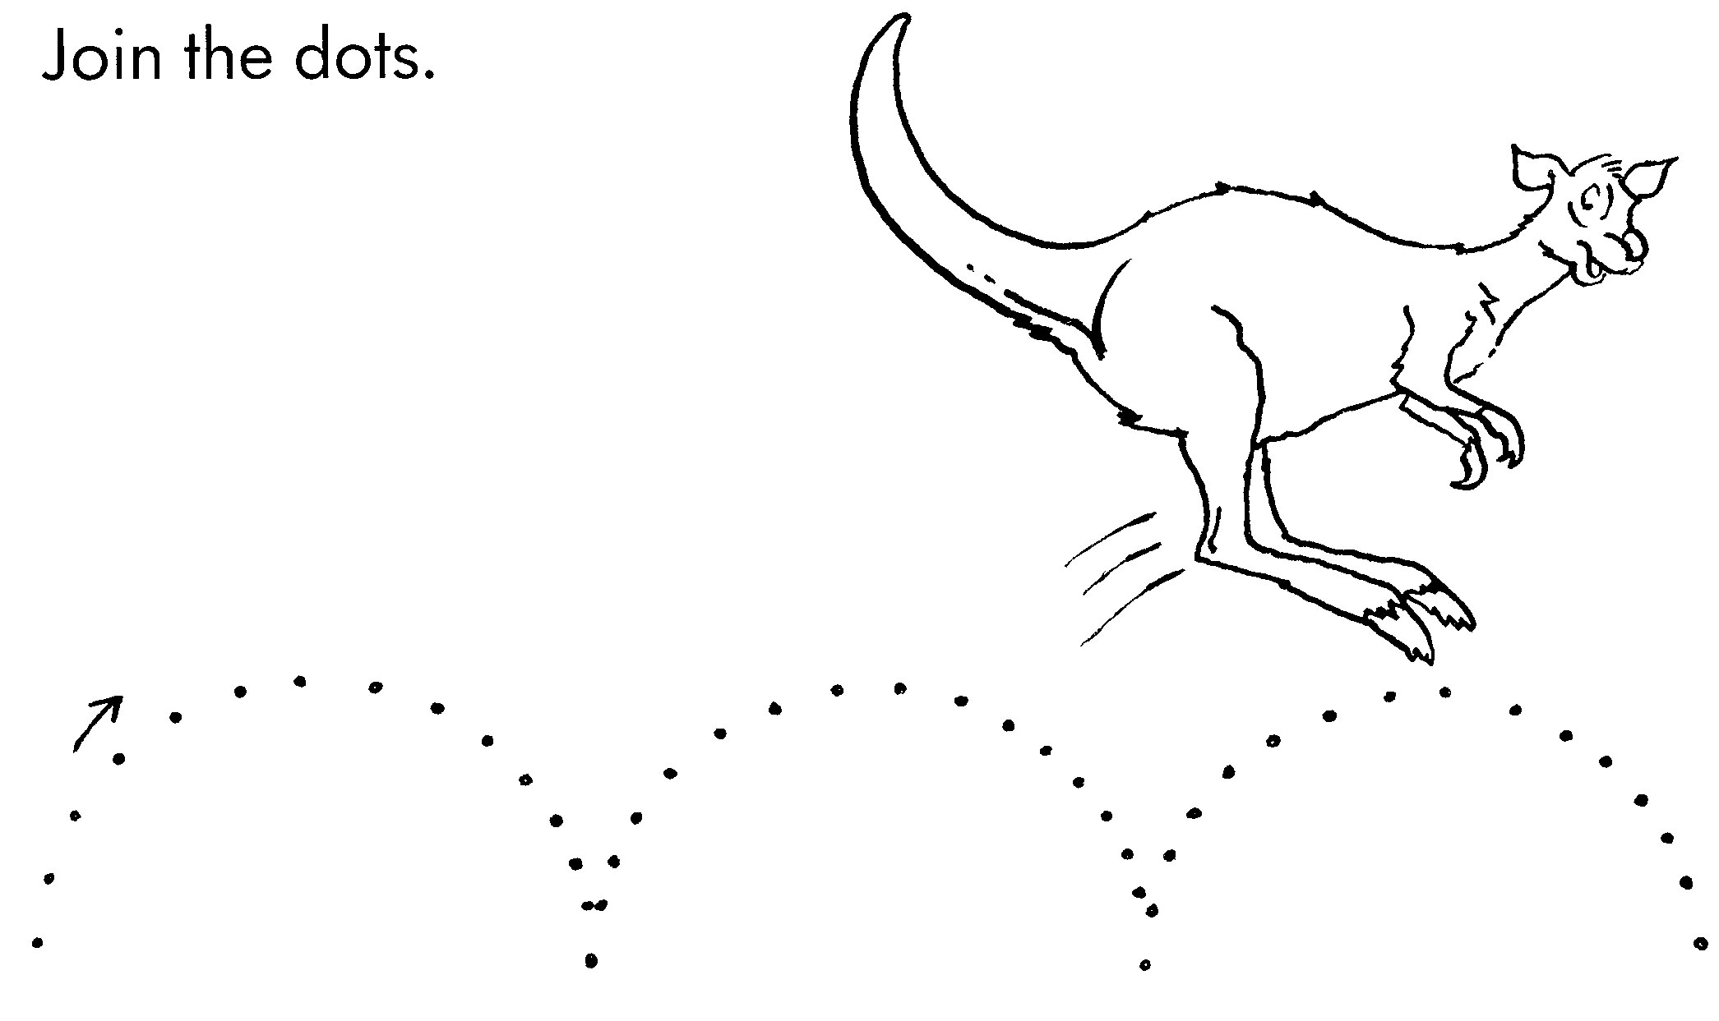

ACTIVITY –

Draw a line to help Trek find the boomerang.

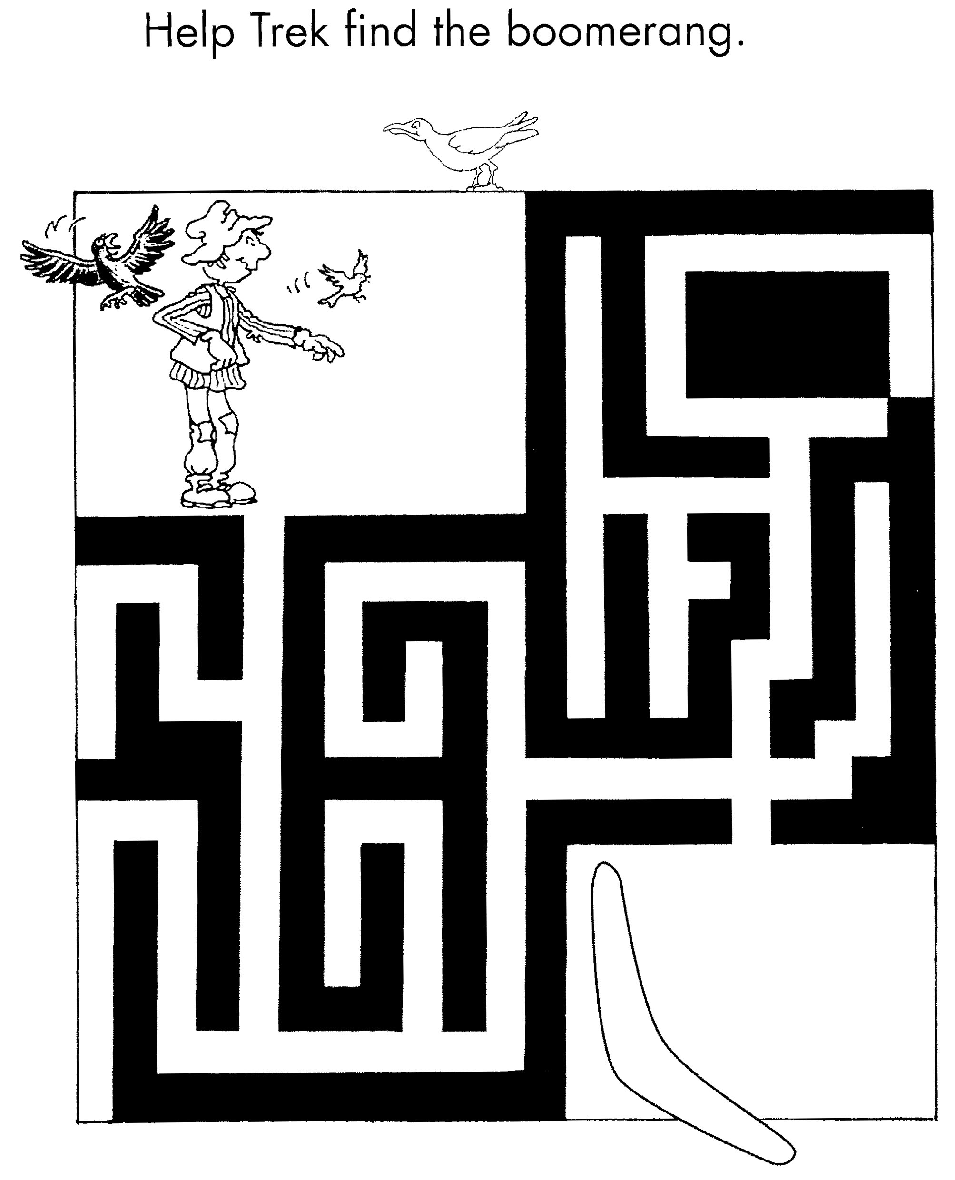

Aim: to aid an understanding of direction.

Trek’s World Travels
Where in the world does Trek learn about
moving around?
Australia

