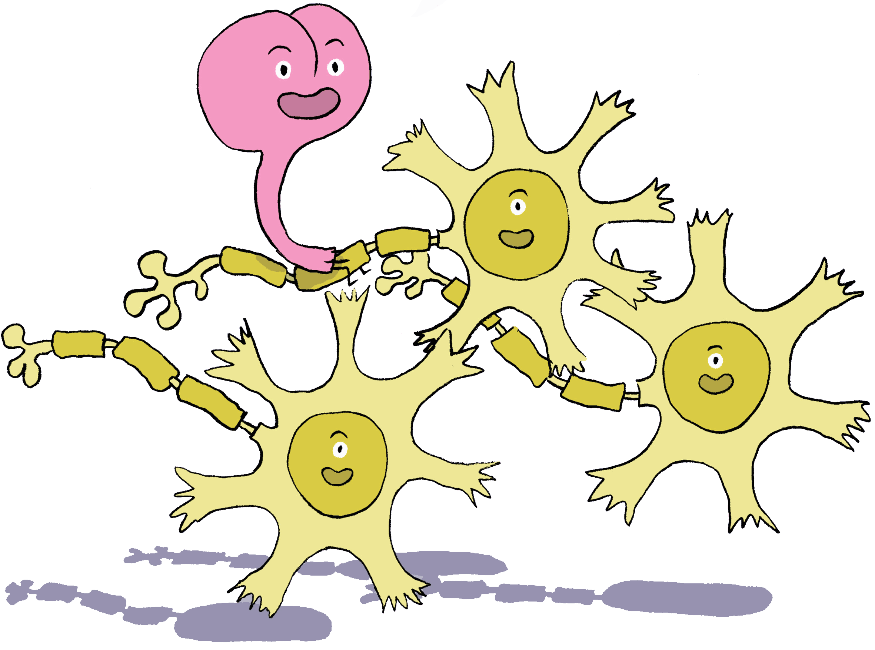
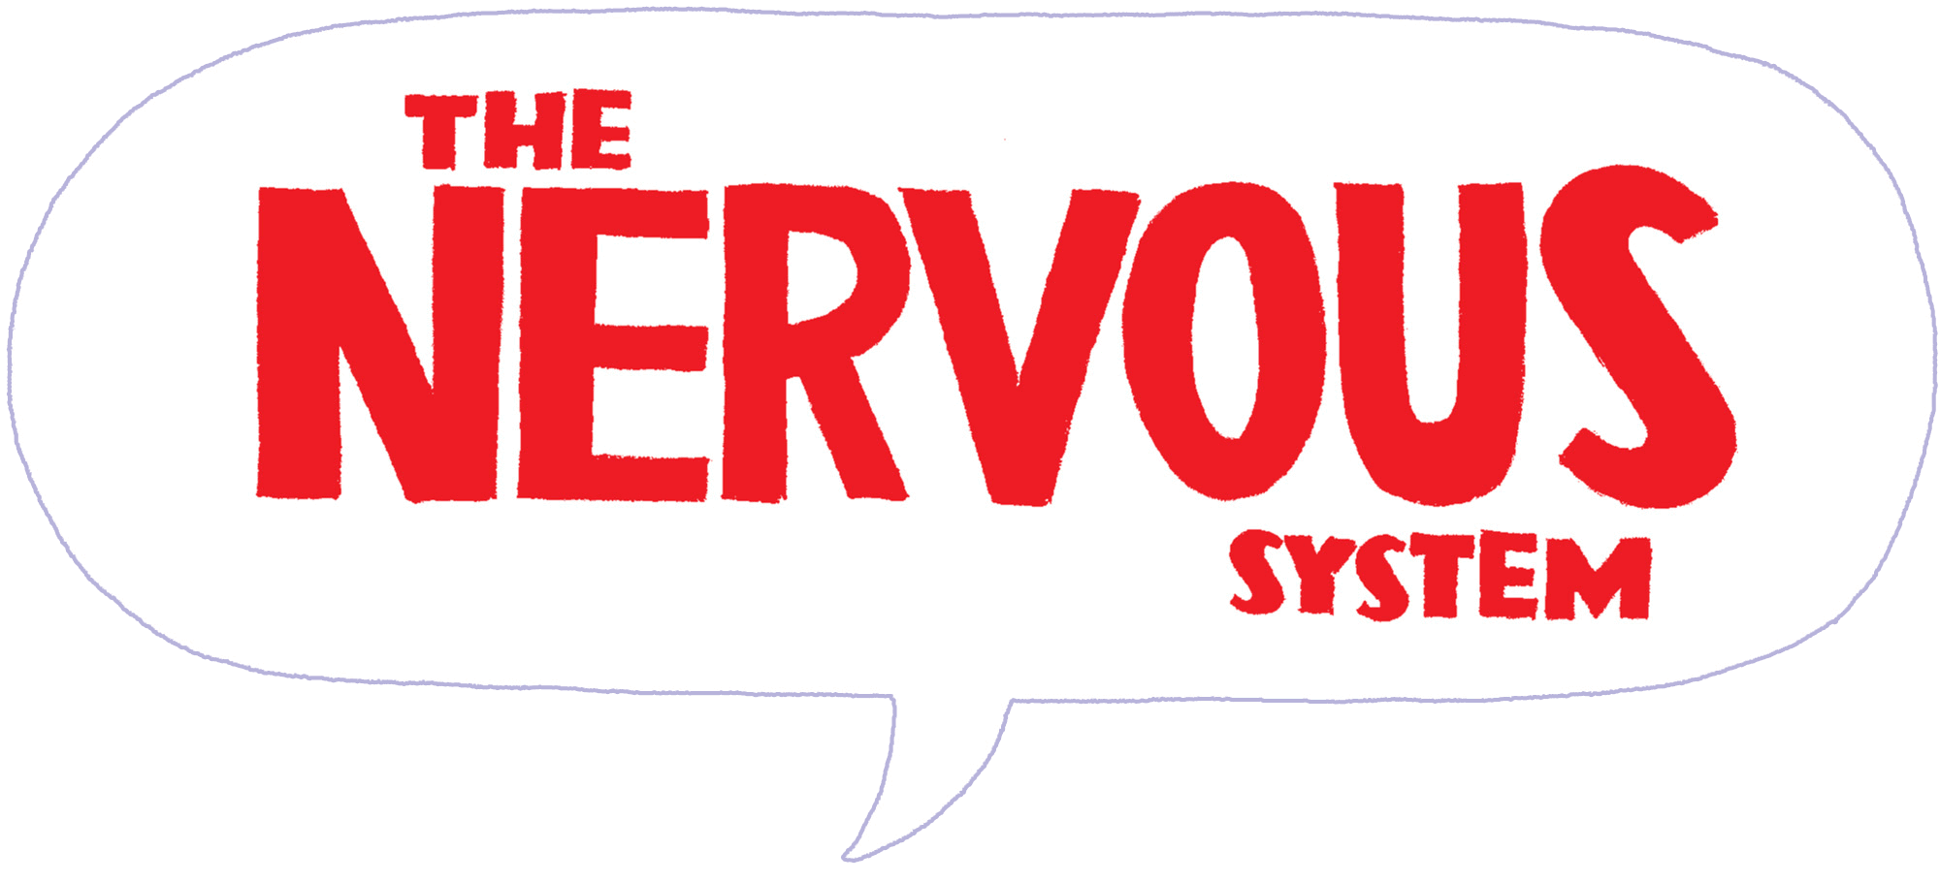

The Nervous System Activity Sheet

1. The human nervous system is made up of billions of cells called _____________________.
2. The nervous system is divided into two main parts, the central nervous system (CNS) and the peripheral nervous system (PNS).
(a) The central nervous system (CNS) is made up of the:
____________________________________________________________________________
(b) What is the role of peripheral nervous system (PNS)?
____________________________________________________________________________________________________________________________________________________________________________________________________________________________________
3. Name the three main parts of the brain.
1. ______________________________________________________
2. ______________________________________________________
3. ______________________________________________________
4. What is the band of nerve fibres called that connect the two hemispheres of the brain?
____________________________________________________________________________
5. Each hemisphere of the brain is divided into four lobes called:
1. ______________________________________________________
2. ______________________________________________________
3. ______________________________________________________
4. ______________________________________________________
6. The right hemisphere controls the right side of the body.
a. True
b. False
7. The part of the brain that coordinates muscular movements with sensory information and helps maintain your body’s sense of balance is the:
a. cerebrum
b. cerebellum
c. thalamus
8. The brain controls actions that you choose to do. Give two examples of voluntary actions.
1. ____________________________________________________________________
2. ____________________________________________________________________
9. The brain also automatically controls actions without being told.
Give two examples of involuntary actions.
1. ____________________________________________________________________
2. ____________________________________________________________________
10. Neurons send messages across the body. Name the three basic parts of a neuron.
1. ____________________________________________________________________
2. ____________________________________________________________________
3. ____________________________________________________________________
11. The nervous system sends messages back and forth in the body in order for you to react. Number the statements below in the correct order to show how you feel pain when you stub your toe?
The brain decodes the signals as a sight, sound, smell, taste, touch, or other sensation.
The message travels along the axon as an electrical impulse.
Messages move from the brain through nerves and out to the body.
A message enters the neuron through the dendrites and goes directly to the cell body.
The message continues as an electrical impulse from one neuron to the next carrying the information to the brain.
You feel pain in your toe.

12. The peripheral nervous system sometimes acts by itself without signalling the brain. These reactions are called ________________________.

ANSWERS:
1. neurons
2. (a) brain and spinal cord
(b) The PNS carries messages to and from the central nervous system to the rest of your body.
3. the cerebrum, the cerebellum and the brain stem.
4. corpus callosum
5. occipital lobe, parietal lobe, frontal lobe, temporal lobe
6. b. False - the right hemisphere controls the left side and the left hemisphere controls the right side of the body.
7. cerebellum
8. walking, speaking, eating
9. blood circulation, digestion, maintaining body temperature
10. 1. the cell body; 2. the axon; 3. the dentrites.
11.
4 | The brain decodes the signals as a sight, sound, smell, taste, touch, or other sensation.
2 | The message travels along the axon as an electrical impulse.
5 | Messages move from the brain through nerves and out to the body.
1 | A message enters the neuron through the dendrites and goes directly to the cell body.
3 | The message continues as an electrical impulse from one neurone to the next carrying the information to the brain.
6 | You feel pain in your toe.

12. Reflexes

