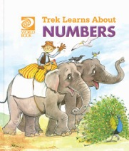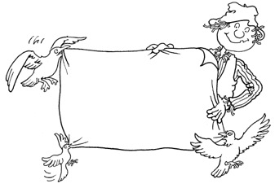**Trek’s Travels –**

**NUMBERS**

**All about numbers**

1. Are there enough chairs for each of the monkeys?   
 Draw a line from each monkey to a chair.

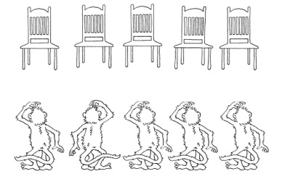

2. Draw a line to join the groups that have the same number of monkeys.

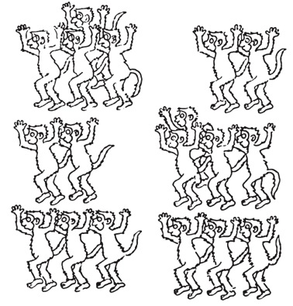

3. How many are there in each group?

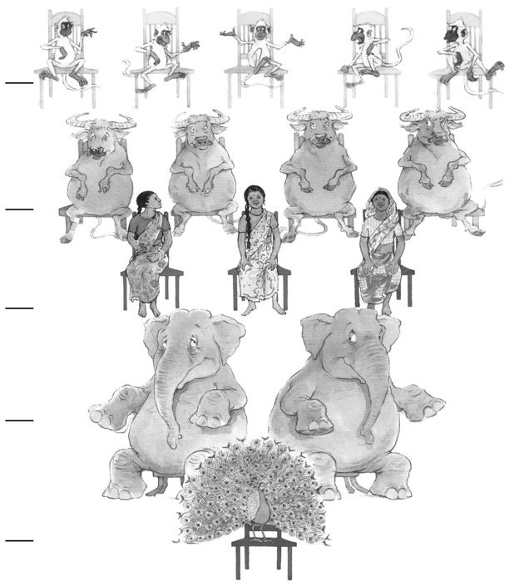

**All about the animals**

1. How many animals are there with two legs? __________________________

2. How many animals are there with four legs? __________________________

4. How many animals can you see with tails? ____________________________

5. How many animals have trunks? ____________________________________

**ACTIVITY –** Count and colour.

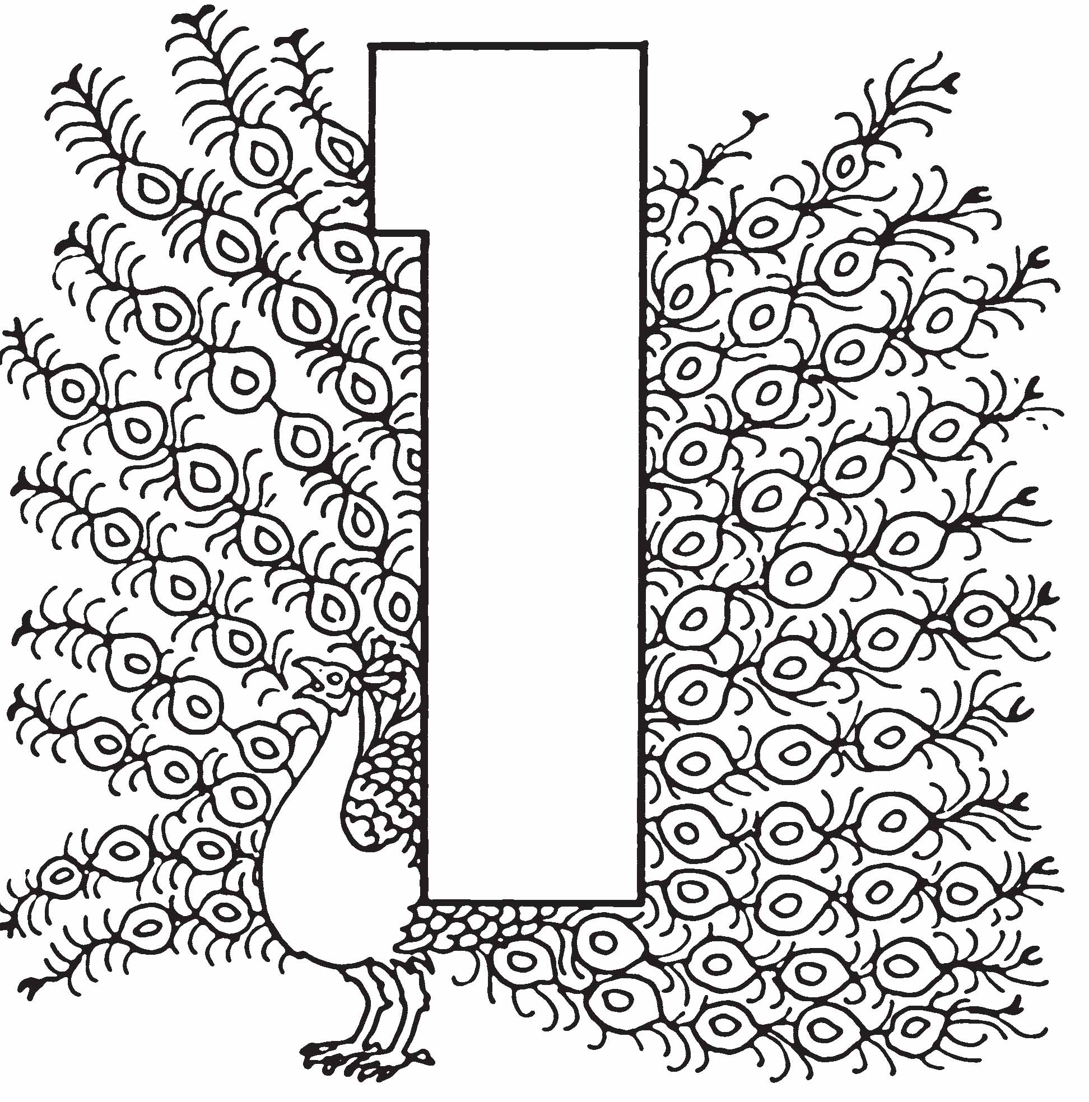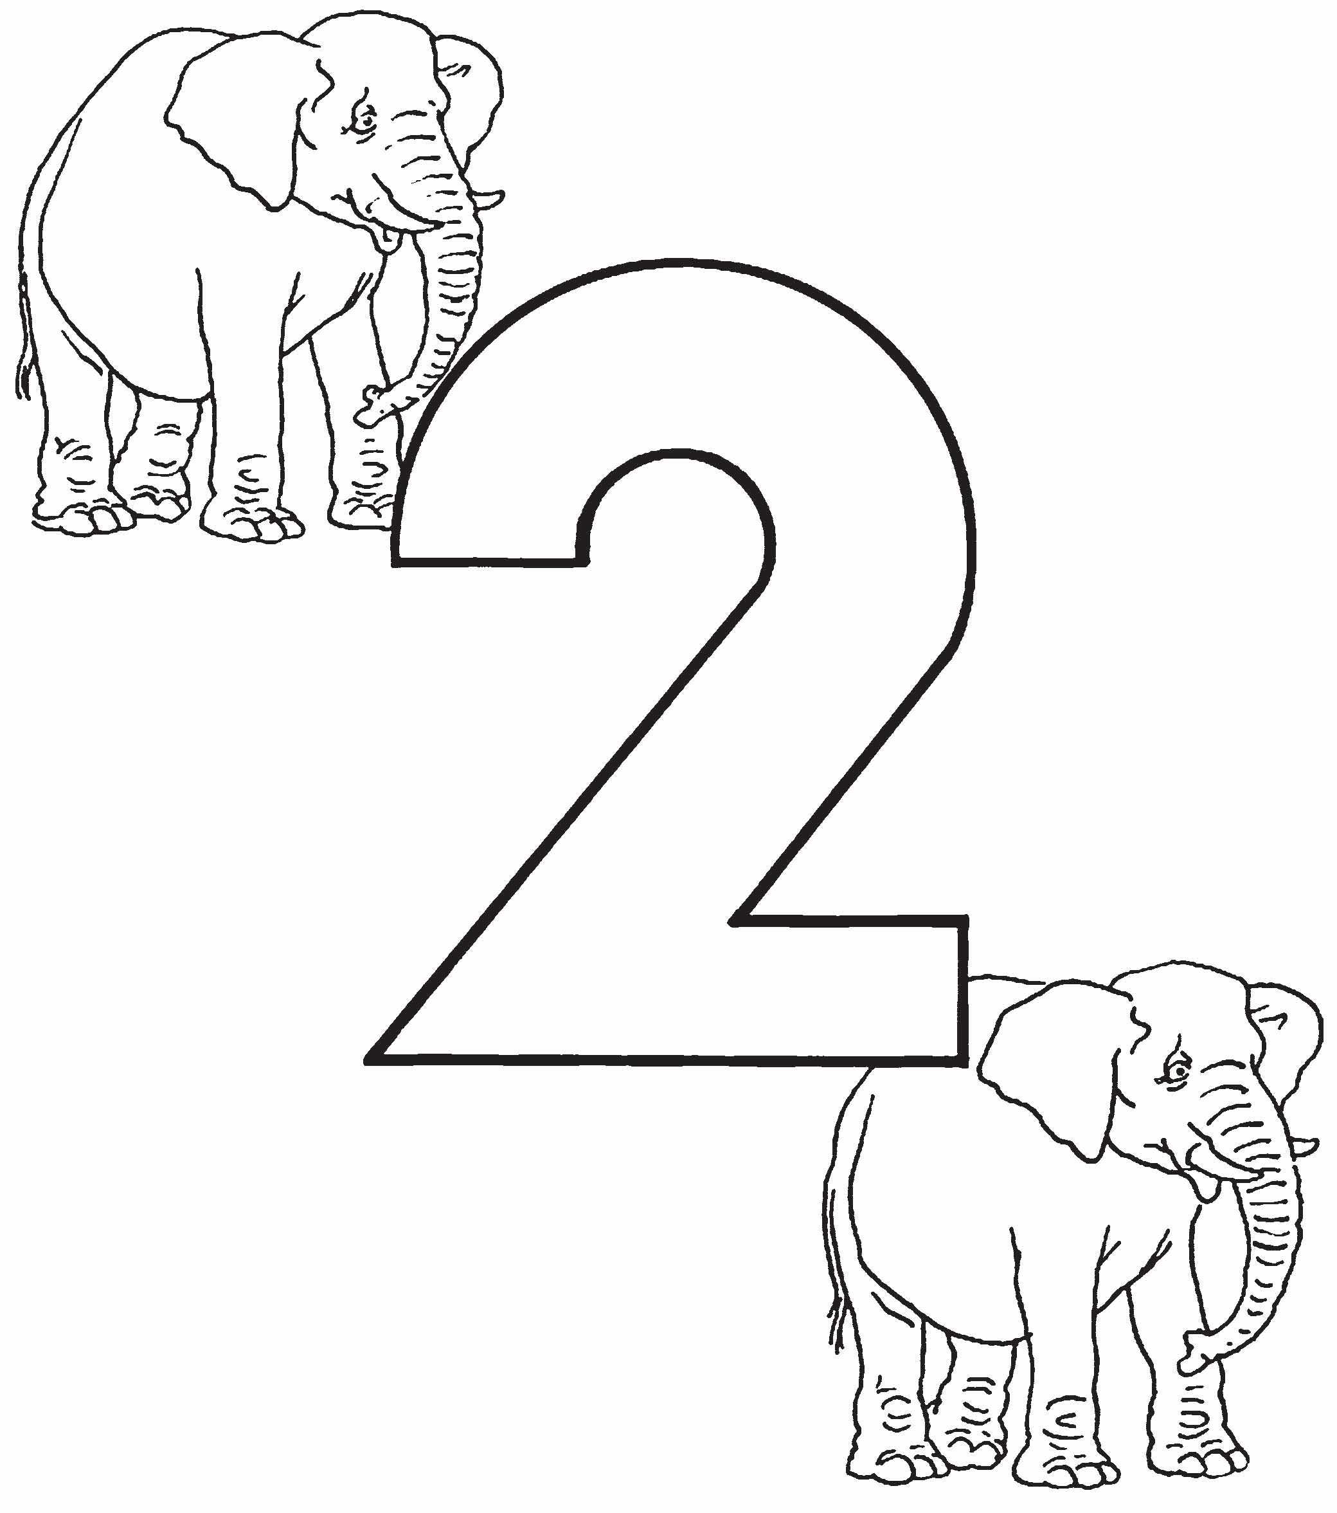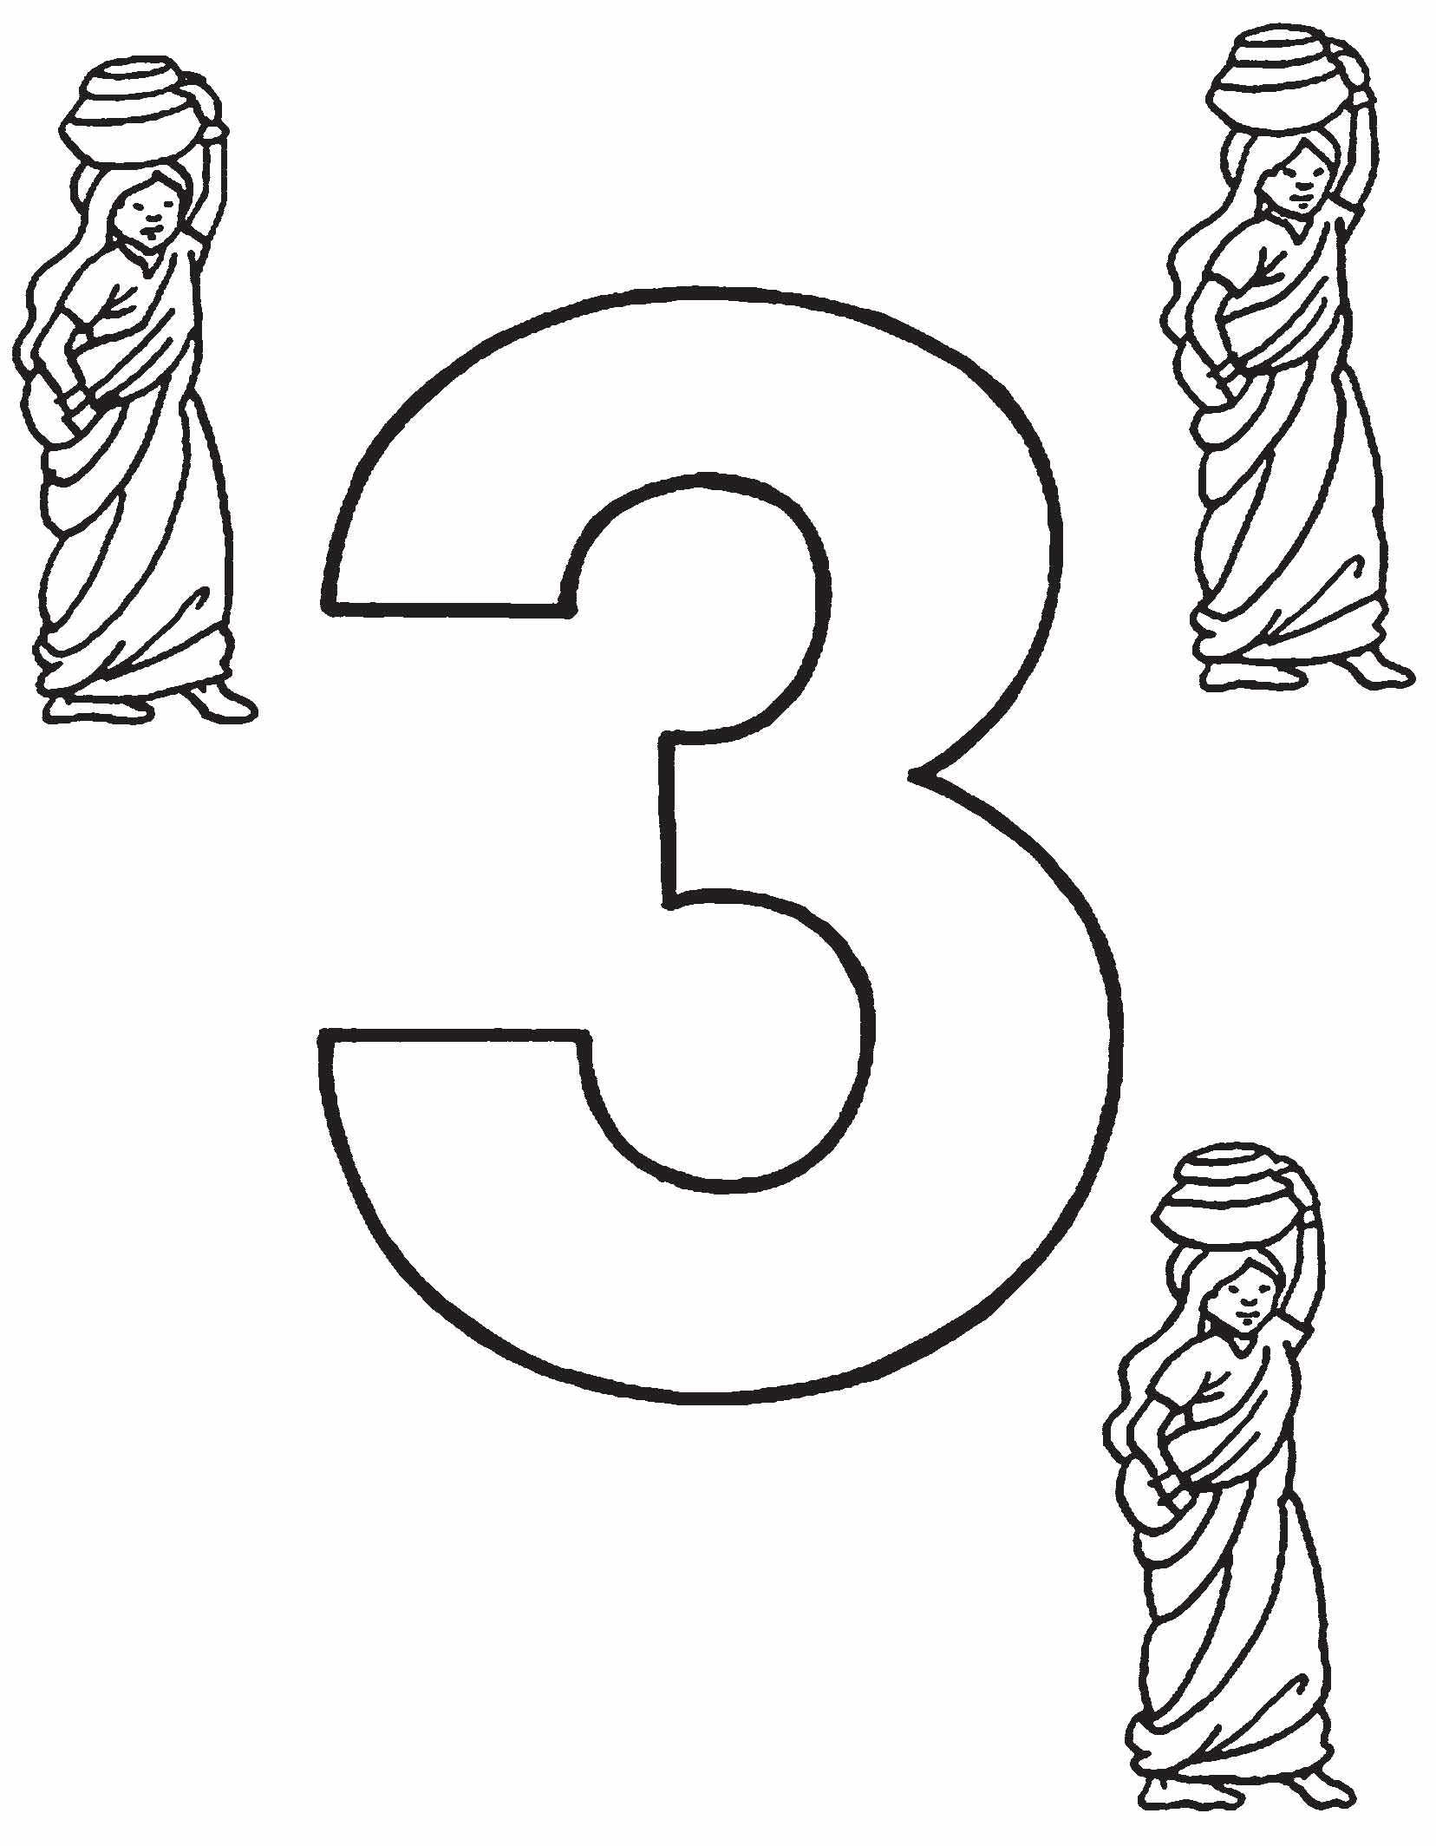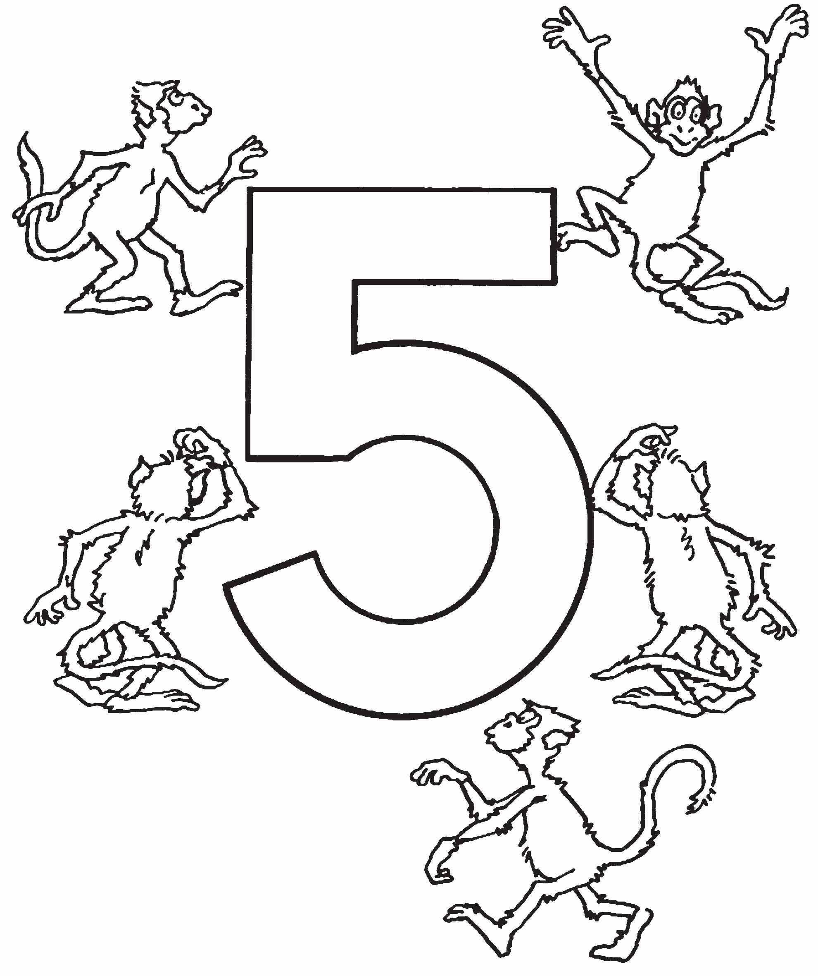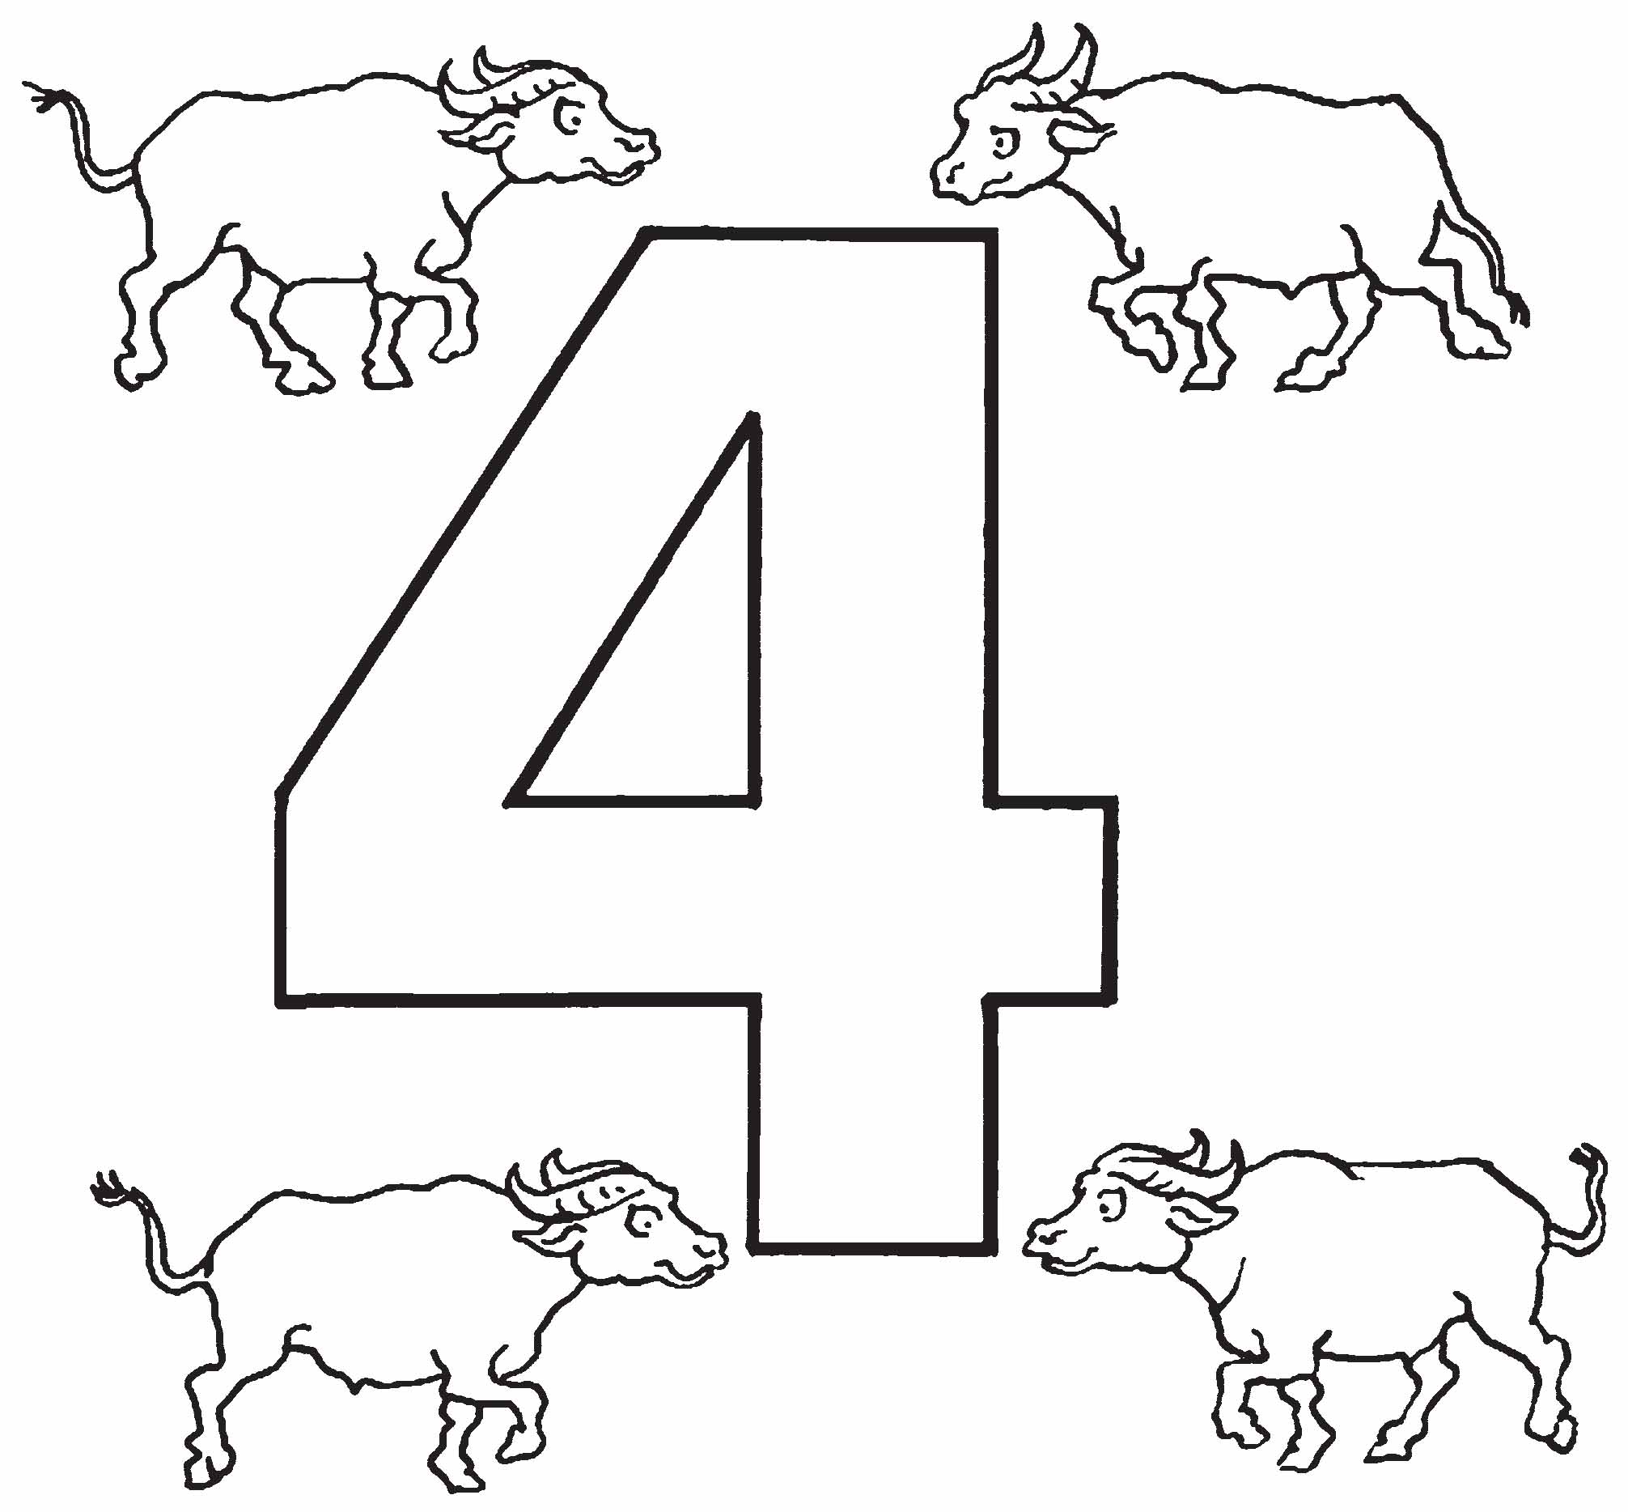

**Trek’s World Travels**

**Where in the world does Trek learn about numbers?**

**India**

