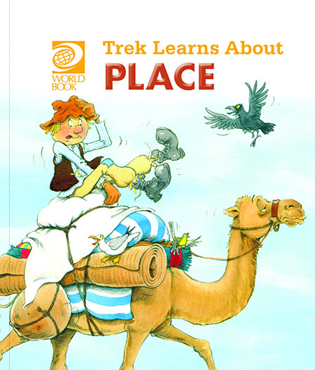
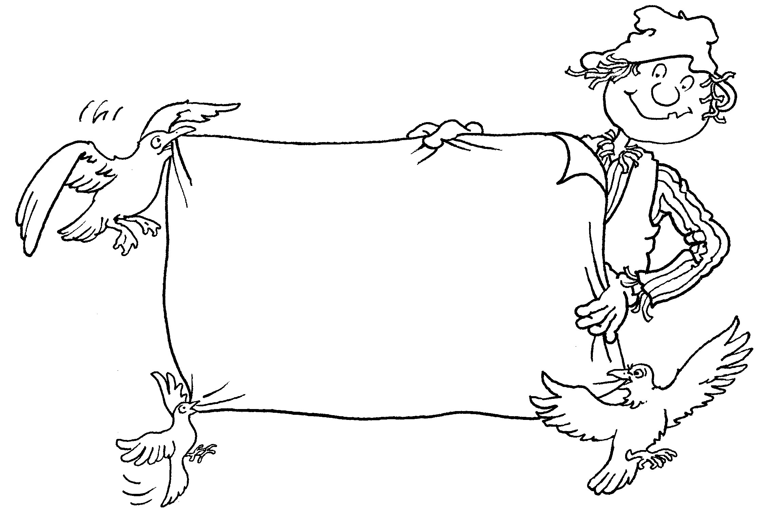
Trek’s Travels –

PLACE

All about place
1. Was Trek in the tent or under the tent?
_________________________________________________________________
2. Was Trek under the palm tree or on the palm tree?
_________________________________________________________________
3. Did Trek go over the sand dunes or between the sand dunes?
_________________________________________________________________
4. Did Trek go near the cave or into the cave?
_________________________________________________________________

All about the desert
1. Do you know what a desert is?
_________________________________________________________________
2. Is it hot or cold in the desert?
_________________________________________________________________
3. Can you remember what animals live in the desert?
_________________________________________________________________

ACTIVITY –

Join the pictures with the words.

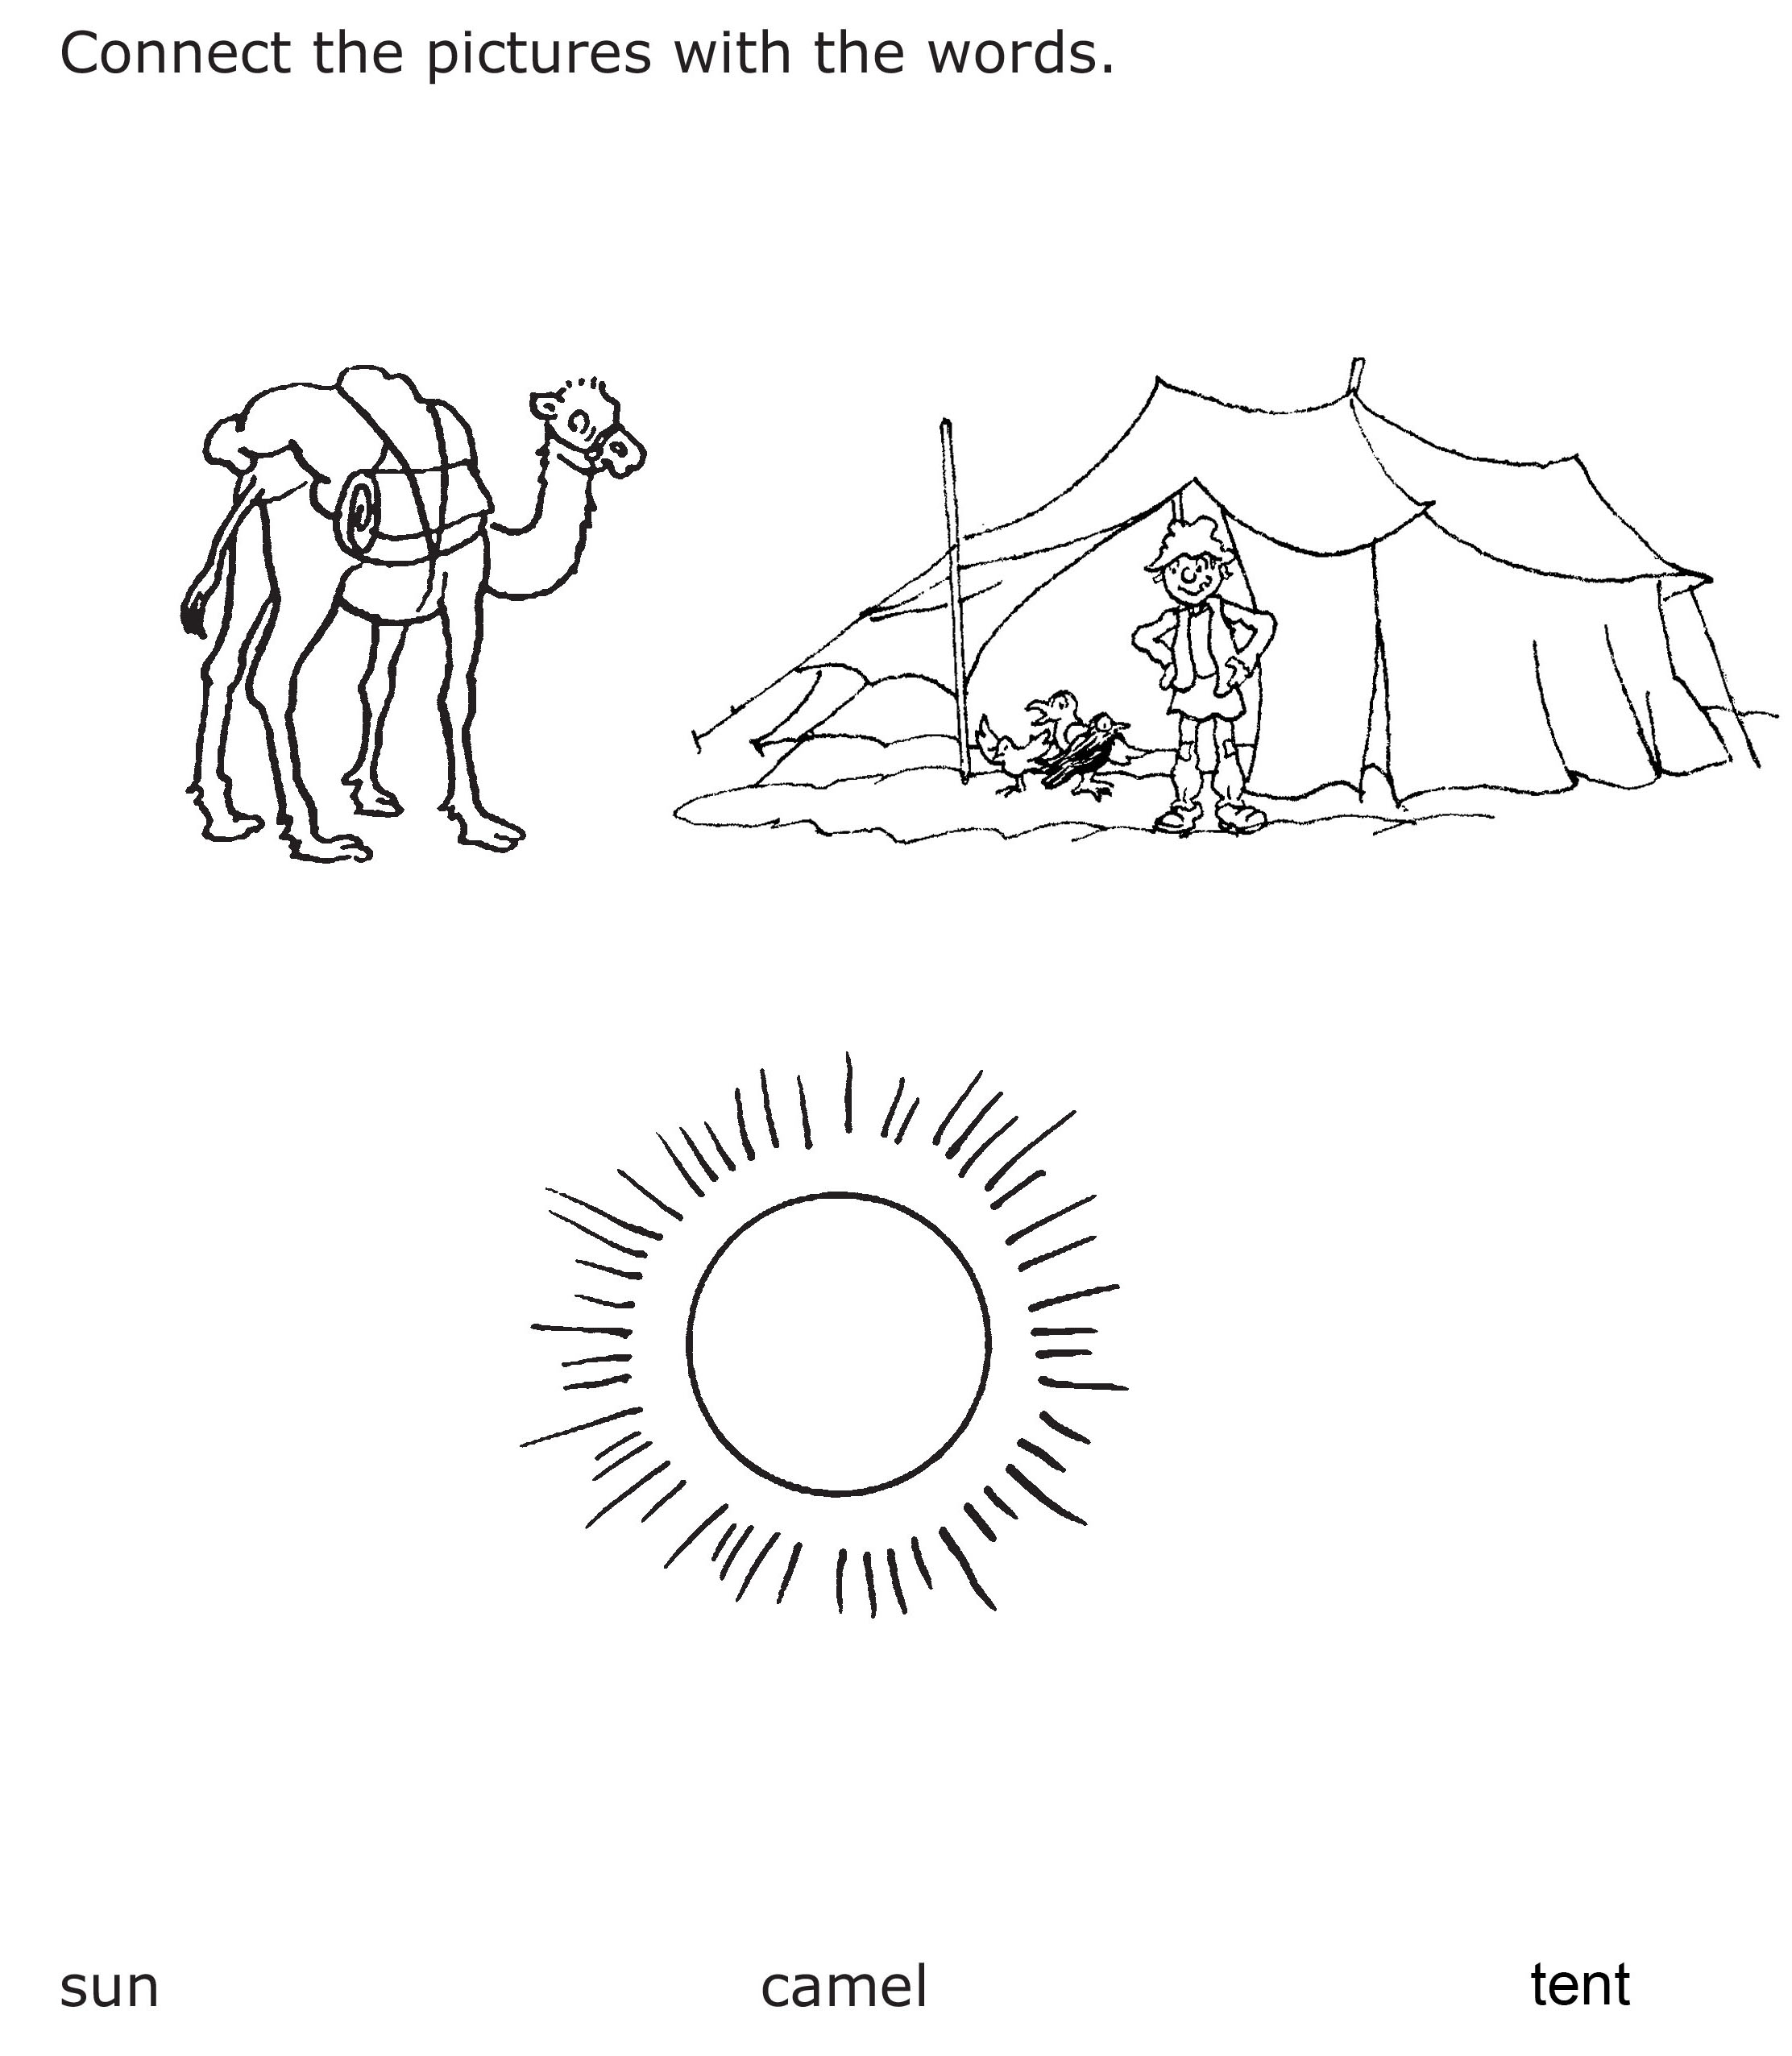

Aim: to match words with objects.

ACTIVITY –

How many birds are on top of the camel? ___________

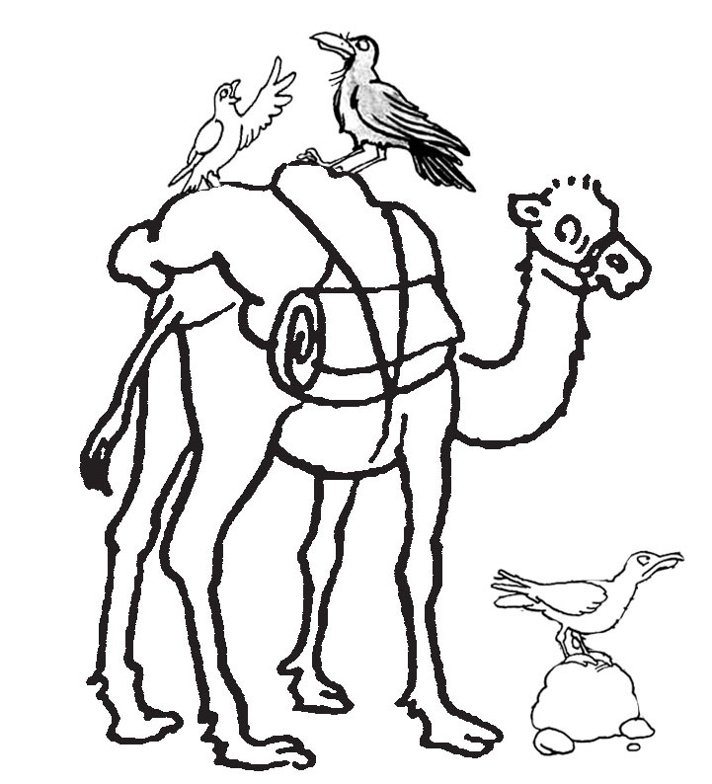

Aim: to understand the language of position.

Trek’s World Travels
Where in the world does Trek learn about place?
Southwest Asia

