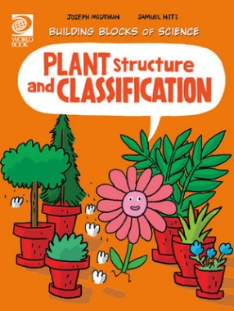
Plant Structure and Classification Activity Sheet
- True or False? All plants are a living thing.
- What is the study of plants called?
________________________________________________________________________
- How do botanists compare plants?
________________________________________________________________________
- Why do scientists give plants a scientific name?
________________________________________________________________________
- What do roots do?
________________________________________________________________________
- What does the stem do?
________________________________________________________________________
- You can tell some plants apart by the shape and structure of their leaves. In the space below, draw examples of leaves you have seen.

- True or false? Thousands of plants produce seeds.
- What do most seed plants produce?
________________________________________________________________________
- Where are seeds made?
________________________________________________________________________
- Name the different parts of the flower.
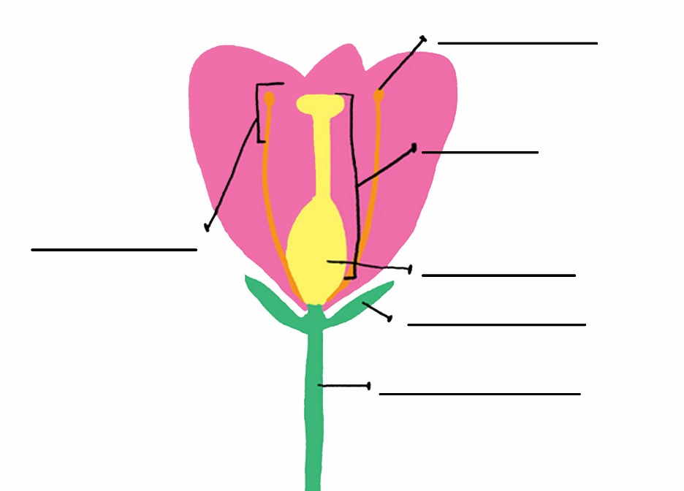
Answers:
- True.
- Botany.
- By their appearance, internal structure and the form of their reproductive organs
- Scientists avoid confusion between species by using their unique scientific name.
- Roots hold the plant in place and take in the water and nutrients from the ground.
- The stem supports the plant and helps the plant get sunlight.
- See page 19 for examples.
- True.
- Special reproductive structures such as flowers.
- Inside the flower.

