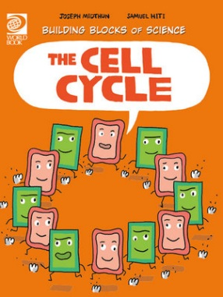
The Cell Cycle Activity Sheet
- True or False? Living things, including you, are organisms.
- True or False? All organisms are made up of tiny units called cells.
- Cells are very small. How can you see cells?
________________________________________________________________________
- Name one thing that plant and animal cells have in common.
________________________________________________________________________
- Where do cells get their energy to function from?
________________________________________________________________________
- True or False? Only plant cells have a nucleus.
- True or False? You have half your mother’s chromosomes and half your father’s chromosomes.
- Name one thing that is different between plant and animal cells?
________________________________________________________________________
- What colour is a plant cell?
________________________________________________________________________
- How are new cells produced?
________________________________________________________________________
- How many cell cycles occurred while you were answering this Activity Sheet?
________________________________________________________________________
- Draw a plant and an animal cell below.

Answers:
- True
- True
- Through a microscope.
- Plant and animal cells have life cycles, a cell membrane, cytoplasm, vacuoles and nucleus.
- Plant and animal cells both use energy from food to live.
- False.
- True.
- Plant cells have a cell wall and chloroplasts, which animal cells do not have.
- Plant cells are green in colour.
- Through a process called cell division.
- Too many to count!

